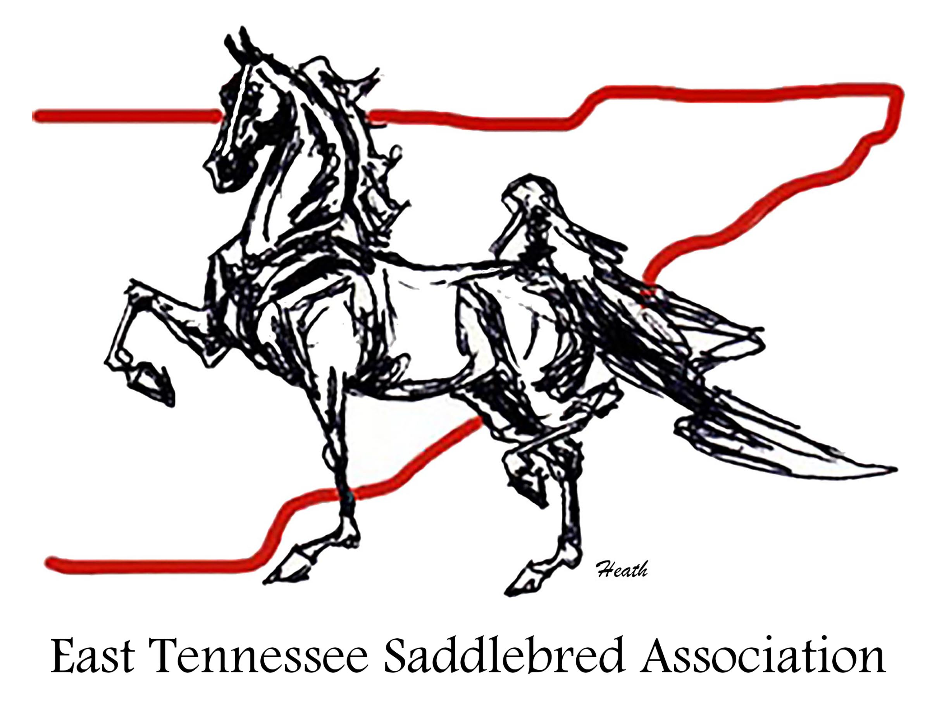
Agenda
ETSA General Membership Meeting
Thursday, April 10, 2025
ETSA Spring Classic Horse Show, Tri State Exhibition Center
McDonald, TN

- Call to Order

- Treasurers Report

- Agenda Items:

- 2025 Midsummer Classic Updates

- New Business:

- Expansion of ETSA branded bunting for Midsummer Classic show arena

- Old Business:

