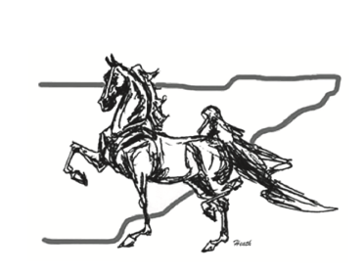
East Tennessee Saddlebred Association
2026 Membership Application
easttnsaddlebred.net

Membership Types & Dues
$25.00 ___ Adult Membership (18 Years & Over)
$35.00 ___ Family Membership (2 Adults & Children 17 & Under)
$20.00 ___ Junior Membership (17 Years & Under)
$20.00 ___ Supporting Membership (Does not show or compete for high point awards)

Membership Expires December 31

Name _______________________________________________________________________________
If family membership, please list the names of the family members and include date of birth for those 17 and under.

_____________________________________________________________________________________
_____________________________________________________________________________________
Address ______________________________________________________________________________
City _________________________________________ State ____________ Zip ___________________
Phone Number(s) (including area code) ____________________________________________________
Email Address ________________________________________________________________________

ETSA members qualify for ASHBA Charter Club Affiliate Membership.

Are you an ASHBA member? Yes ___ No ___ ASHBA Number ________________________________
Signature _______________________________________________ Date _________________________

Please mail the completed form and membership dues made payable to ETSA to:

East Tennessee Saddlebred Association

Anita Miller
700 Clear Springs Rd.
Limestone, TN 37681
(423) 823-1740

FOR ETSA USE ONLY
Payment Method ____________________
Date Received ______________________

If you wish to participate in the High Point Awards Program, horses must be nominated and must meet the qualification criteria. Riders must be nominated and birthday provided for equitation and academy. Please refer to the qualification criteria on the nomination form. Points will not be awarded for shows prior to nomination and payment. You can qualify for high point by sponsoring classes at ETSA Spring Classic or ETSA Midsummer Classic and can include sponsorship payment with your membership. You may also volunteer at one of these shows.

ETSA Spring Classic Class Sponsorship: $25
Class(es) you wish to sponsor: ____________________________________________________________________

ETSA Midsummer Classic Sponsorships: $750 Corporate, $500 Jackpot Stake, $125 Championship/Stake, $50 Qualifying Class, $30 Trophy/Ribbons
Class(es) you wish to sponsor and/or other sponsorship options: _________________________________________
____________________________________________________________________________________________

ETSA High Point Award Program Nomination
Qualification for High Point Awards
- Both the recorded owner and the rider MUST BE current ETSA members in good standing (this will be enforced).
- The horse must be nominated in order to receive points in performance divisions.
- The rider must be nominated and provide their birthday in order to receive points in academy and equitation divisions.
- Must show in a minimum of three affiliated shows (two affiliated shows for academy).
- Points will be awarded from the date the nomination is paid for and received (postmark will determine date) and points will not be awarded for shows prior to nomination and payment.
- The nominator must help with the ETSA Spring Classic or ETSA Midsummer Classic by serving on the show committee, working at one or both shows, selling sponsorships, or sponsoring classes, ribbons, etc.
- Any horse purchased during the year must be nominated by form or email to Anita Miller for points to be awarded.

I understand the qualifications listed above and wish to nominate the following horse(s) and/or rider(s) to the ETSA High Point Awards Program.
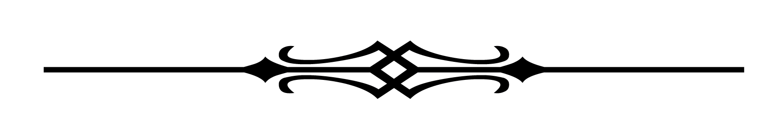
Horse _______________________________________________________________________________
Rider (specify academy or equitation) ______________________________________________________
Rider Birthdate (for academy or equitation) _________________________________________________
What division do you plan to show in? _____________________________________________________

Horse _______________________________________________________________________________
Rider (specify academy or equitation) ______________________________________________________
Rider Birthdate (for academy or equitation) _________________________________________________
What division do you plan to show in? _____________________________________________________

Horse _______________________________________________________________________________
Rider (specify academy or equitation) ______________________________________________________
Rider Birthdate (for academy or equitation) _________________________________________________
What division do you plan to show in? _____________________________________________________

Please use a separate sheet of paper to submit additional horses or riders.
Nominations may be made by emailing the above information to anitaamiller7@gmail.com; registering on the ETSA website, easttnsaddlebred.net; or by mailing nominations to:

Anita Miller
700 Clear Springs Rd
Limestone, TN 37681

PayPal payment is available by going to the PayPal website/app and searching the club’s email address, easttnsaddlebred@gmail.com

