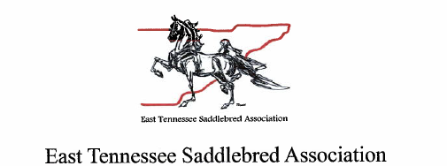
Agenda
General Membership Meeting
April 17, 2026

- Call to Order

- Treasurers Report

- Committee Report

- New Business
  - Change of Article V – Meetings
Article V currently reads as follows:
General Meetings: Unless otherwise ordered by the ETSA or Executive Board, there should be three (3) general meetings of the membership for ETSA each year.

A motion has been made to change the number of meetings each year from three (3) to two (2).

- Old Business

- Meeting Adjourned

